A186-Afr-Egy-Ushabti-Ptolemaic Dynasty-Winged Scarab Pectoral

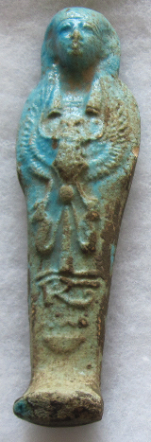 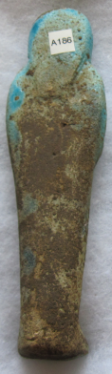

Figs. 1-2. Ushabti-Ptolemaic Dynasty-Winged Scarab Pectoral

**Formal Label:** Ushabti-Ptolemaic Dynasty-305-30 BCE - Winged Scarab Pectoral

**Display Description: This mummiform Ushabti wears a plain lappet wig with a single horizontal band and a** Winged Scarab Pector**. Below the pectoral is four-part vertical hieroglyphic of the owner.**

**Accession Number: A264**

**LC Classification:** DT64

**Date or Time Horizon:** 305-30 BCE

**Geographical Area: Delta, Alexandria, Egypt**

**Map, GPS Coordinates:** 31.17913 29.99565; 31º10'44.88" N 29º59'44.33" E



**Cultural Affiliation:** Ptolemaic Dynasty

**Medium:** Blue faience

**Dimensions: 162.71 mm; 6.406 in  
Weight: 131 gm; 4.5 oz**

**Provenance: unknown**

**Condition: original**

**Discussion:**

**References:**

Aubert, J.-F. et L. Aubert. 1974. *Statuettes Egyptiennes: Chaouabtis, Ouchebtis.* Paris, 1974.

Janes, Glenn. 2002. *Shabtis. A Private View, Ancient Egyptian Funerary Statuettes in European Private Collections.* Paris: Cybèle.

Newberry, Percy E. 1930-1957. *Funerary Statuettes and Model Sarcophagi.*  Le Caire: Impr. de l'Institut français d'archéologie orientale.

Schneider, Hans D. 1977. *Shabtis - An Introduction to the History of Ancient Egyptian Funerary Statuettes. With a Catalogue of the Collection of Shabtis in the National Museum of Leiden*. 3 volumes, Leiden: Rijksmuseum van Oudheden Te Leiden.

Schlögl, Hermann and Andreas Brodbeck. 1990. *Ägyptische Totenfiguren aus öffentlichen und privaten Sammlungen der Schweiz.* Orbis Biblicus et Orientalis, Series Archeologica, 7. Göttingen, Vandenhoeck & Ruprecht; Freiburg Schweiz, Universitätsverlag.